A Project Report on

**“V-PRACTICAL”**

Submitted by

**Shubham Pote – 18202A0002**

**Yash Hajare – 18202A0024**

**Sanket More – 18202A0025**

**Prasad Kashid – 18202A0030**

Under the guidance of

**Prerana Jalgaonkar**

Head of the Department

**Mrs. Yogita Jore**

**Department of Information Technology**

(NBA Accredited)

**Vidyalankar Polytechnic**

**Wadala (e), Mumbai – 400 037**

**Maharashtra State Board of Technical Education, Mumbai**

**2020 – 21 2020**

|  |
| --- |
| **Institute Vision** |

To achieve excellence in imparting **Technical Education** so as to meet the **Professional and Societal needs**.

|  |
| --- |
| **Institute Mission** |

* Developing **technical skills** by imparting knowledge and providing hands on experience.
* Creating an environment that nurtures **ethics, leadership and team building**.
* Providing **industrial exposure** for minimizing the gap between academics & industry.

|  |
| --- |
| **Program Vision** |

To become a leading center in the domain of Information Technology where learners are introduced to the concepts and implementation of technologies.

|  |
| --- |
| **Program Mission** |

M1:Encouraging academic excellence and a passion for learning through the use of learner-oriented teaching methodologies.

M2:Providing an environment that inculcates ethics and effective soft-skills and focuses on the development of learners.

M3:Establishing and reinforcing a symbiotic institute-industry interface so that learners can gain exposure to real-life applications of Information Technology.

|  |
| --- |
| **Program Education Objectives** |

PEO 1: Provide socially responsible, environment friendly solutions to Information technology related broad-based problems adapting professional ethics.

PEO 2: Adapt state-of-the-art Information Technology broad-based techniques to work in multi-disciplinary work environments.

PEO 3: Solve broad-based problems individually and as a team member communicating effectively in the world of work.

|  |
| --- |
| **Program Outcomes** |

**Basic and Discipline specific knowledge:** Apply knowledge of basic mathematics, science and engineering fundamentals and engineering specialization to solve the engineering problems.

**Problem analysis:** Identify and analyse well-defined engineering problems using codified standard methods.

**Design/ development of solutions:** Design solutions for well-defined technical problems and assist with the design of systems components or processes to meet specified needs.

**Engineering Tools, Experimentation and Testing:** Apply modern engineering tools and appropriate technique to conduct standard tests and measurements.

**Engineering practices for society, sustainability and environment:** Apply appropriate technology in context of society, sustainability, environment, and ethical practices.

**Project Management:** Use engineering management principles individually, as a team member or a leader to manage projects and effectively communicate about well-defined engineering activities.

**Life-long learning:** Ability to analyse individual needs and engage in updating in the context of technological changes.

|  |
| --- |
| **Program Specific Outcomes** |

**Modern Information Technology:** Use latest technologies for operation and application of information.

**Information Technology Process:** Maintain the information processes using modern information and communication technologies.

VP logo

**Certificate**

This is to certify that the following students

**18202A0002 – Shubham Pote**

**18202A0024 – Yash Hajare**

**18202A0025 – Sanket More**

**18202A0030 – Prasad Kashid**

Have completed the Project on

……………………..

A partial fulfillment of the requirement of Third Year Diploma in Information Technology affiliated to Maharashtra State Board of Technical Education, Mumbai for the Academic Year 2020-21.

Internal Examiner External Examiner

Mr. Ashish Ukidve

Mrs. Yogita Jore

Mrs. Prerana Jalgaonkar

Project Guide Head of Department Principal

**Acknowledgment**

We would like to express our deepest appreciation to all those who provided us the possibility to complete this report. A special gratitude we would give to our final year project guide, Mrs. Prerana Jalgaonkar, whose contribution in stimulating suggestions and encouragement, helped us to coordinate our project especially in writing this report.

Furthermore, we would also like to acknowledge with much appreciation the crucial role of all those who gave the permission to use all required equipment’s and the necessary materials to complete the task.

A special thanks goes to my teammates, who will help us to develop this model and give suggestion about the task to be performed. Last but not the least, special thanks goes to the head of the project, who had invested his full effort in guiding the team in achieving the goals. We would like to appreciate the guidance given by our mentor as well as the panels especially in our project presentation that has improved our presentation skills. Thanks to their comment and advices.

**Abstract**

V-Practical is an integral part of smart education. There are many V-Practical systems that are widely available to educational institutions. The challenge is to easily integrate the V-Practical system into a smart educational environment based on the requirements of the users. The V-Practical services rely on a software system that allows access to all the materials for the educational process and makes them electronically available to all the students on the Internet whenever they need and wherever they are.

**Table of Contents**

|  |  |  |
| --- | --- | --- |
| **Sr. No** | **Title** | **Pg. No** |
| 1 | Acknowledgment |  |
| 2 | Abstract |  |
| 3 | Introduction | 1 |
| 4 | Review of Literature | 3 |
| 5 | Plan of Work | 6 |
| 6 | System Requirement | 8 |
| 7 | Designing | 10 |
| 8 | Module Description | 14 |
| 9 | Testing | 16 |
| 10 | Advantages and Disadvantages | 18 |
| 11 | Applications | 20 |
| 12 | Screenshots | 22 |
| 13 | Conclusion | 30 |
| 14 | Bibliography | 32 |

**List of Tables and Figures**

|  |  |  |
| --- | --- | --- |
| **Sr. No** | **Title** | **Pg. No** |
| 1 | Plan Of Work | 7 |
| 2 | Use-Case Diagram | 11 |
| 3 | E-R Diagram | 12 |

**List of Tables and Figures**

|  |  |  |
| --- | --- | --- |
| **Sr. No** | **Title** | **Pg. No** |
| 4 | Flow Chart | 13 |
| 5 | Output Screenshot | 23 |

**CHAPTER 1**

**INTRODUCTION**

# 1. INTRODUCTION

Our Project Title is V-Practical.A system based on formalized submission of practical and assignment but with the help of electronic resources is known as V-Practical. While submission can be based in or out of the classrooms, the use of computers and the Internet forms the major component of submitting resource V-Practical. However, with the rapid progress in technology and the advancement in systems, it is now embraced by the masses. Practical submission can also be termed as a network enabled transfer of skills and knowledge, and the delivery of education is made to a large number of recipients at the same or different times.

**CHAPTER 2**

**REVIEW OF LITERATURE**

# 2. REVIEW OF LITERATURE

In recent years, the quantity of online applications in Kurdistan Region of Iraq is growing steadily due to better presentation of internet connection bandwidth from local ISPs. This growth has notably influenced the governmental organizations to improve their web services. Therefore, a movement of online journal system is convincing many institutions and universities to implement an infrastructure for gathering and issuing electronic journals (e-journals). Over the last few years, e-journals are considered to be significant resources of preserving scientific communication amongst researchers. Starting from the late 1970s, the first growth of e-journals begins and continued till the early 1990s. A second period of e-journals evolution began in early 1990s where the World Wide Web is invented. So, similarly to printed versions of journals, publishers began to publish e-journals on the Web.[1]

A third period of e-journal evolution began from year 2000 where advanced technologies such as searching and filtration features were incorporated in the e-journals [2].

Time management [and] planning, coordinating and organizing ability [are some of] the attributes employers expect to find in graduate recruits’ (The Pedagogy for Employability Group, 2006, p. 4). Providing students with the opportunity to develop transferable skills so that they are fully ‘aware of the importance of proper planning and time management.[3]

Today‘s education system is looking like web that is spreading itself in the society. If education is given in interesting ways, then students do not get bored. Like; taking online Quiz, submit online practical, View result of quiz etc. Online examination should allow setting quiz of all types (like, MCQ, Short, Match), conducting exam reports etc. Some of the problems faced by manual examination systems are delays in result processing; filling poses a problem, filtering of records are not easy. Maintenance of the system is also very difficult and takes lot of time and effort. Most of above issues can be resolved by online examination.

The Quiz activity allows to design and set quizzes that consisting variety of question types, like MCQ, matching, true-false, short answer type‘s questions. [4]

Only six per cent of partially online assessable units had a final exam that could be taken online. Of the partially online assessable units without an online final exam, 83 per cent had a traditional pen and paper final exam, indicating that the use of final exams is quite widespread. Overall, 84 per cent of partially online assessable units had a final exam. (Byrnes & Ellis, 2006) [5]

Journals constitute an important part of a library collection being the most important vehicle for global scholarly communication. Tremendous developments in ICT in the recent years have given amazing boost to electronic publishing. As a result the information which is being generated at intense pace from all the directions worldwide for all the themes is now being published in form of electronic journals (e-journals). Anyone with access to a computer equipped with a modem and suitable software can produce and distribute an e-journal through a computer network, thus journal publishing is being democratized. Usually, e-journals are published as electronic equivalents of their print counterparts but recently there is an increase in number of scholarly journals which are being published only electronically. As a result, e-journals have emerged as vital components of information resources of a library and play an imperative role in the distribution of prime information. E-journals have been defined in different ways by different authors. An early definition by McMillan (1991) described electronic journals as "any serials produced, published, and distributed via electronic networks such as Bitnet and the Internet." [6]

**CHAPTER 3**

**PLAN OF WORK**

# 3. PLAN OF WORK

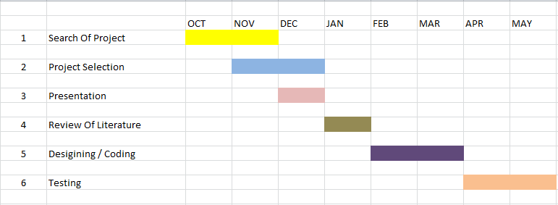

Fig.3.1: Plan Of Work.

**CHAPTER 4**

**SYSTEM REQUIREMENTS**

## 4.1 HARDWARE REQUIREMENTS

System : Intel(R) Core(TM) i3-6006U CPU @ 2.00GHz 2.00 GHz

Hard Disk : 1TB

RAM : 4 GB

## 4.2 SOFTWARE REQUIREMENTS

Operating system: Windows

Database: MySQL

Programming Language: PHP, HTML, CSS,

IDE Used for Coding: Sublime Text

**CHAPTER 5**

**DESIGNING**

## 5.1 USE-CASE DIAGRAM

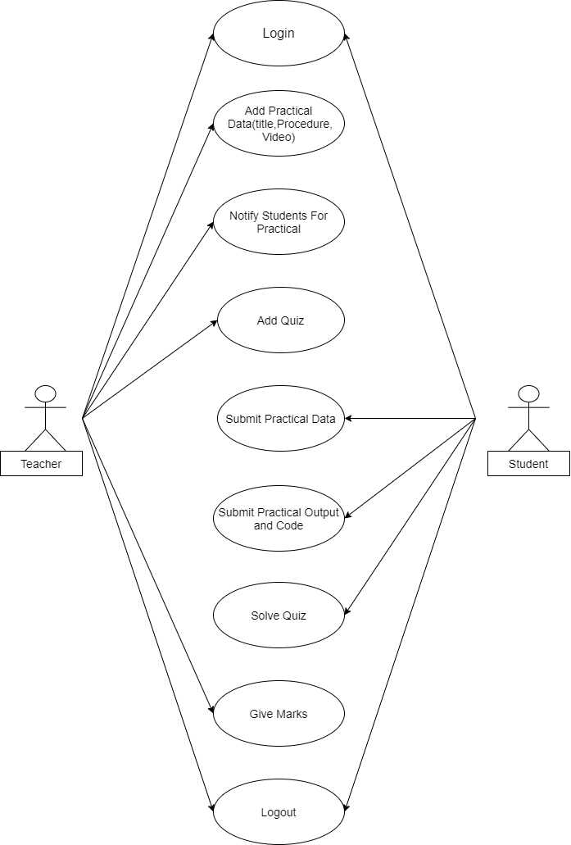

Fig 5.1: Use-Case Diagram

## 5.2 ER DIAGRAM

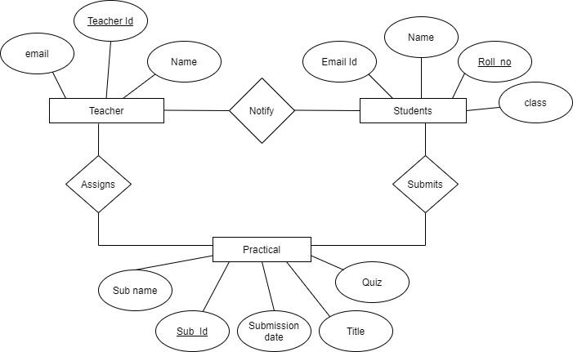

Fig 5.2: ER Diagram

**5.3 Flow Chart**

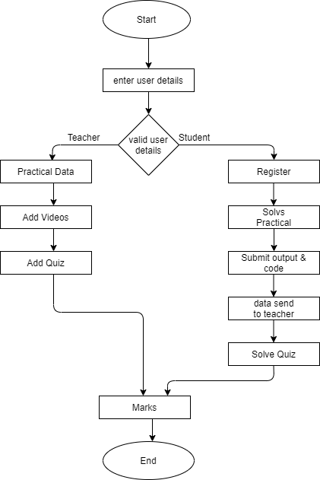

Fig 5.3. : Flowchart

**CHAPTER 6**

**MODULE DESCRIPTION**

# 6. MODULE DESCRIPTION

Our system consists of following modules:

1. **Student Registration**
2. **Student Login**
3. **Teacher Login**
4. **Upload and Download Practical**
5. **Upload and View Video**
6. **Create and Solve Quiz**
7. **Notify Students**

**1. Student Registration:**

Students have to register in V-Practical. Students have to fill the data required for registration to get successfully registered. Once he/she will get successfully registered then he/she can log in.

**2. Student Login**

After successful registration student can log in into V-Practical. Then student can use V-Practical Application for submitting practical online. Student will get options like Solve Quiz, Upload Practical and View Videos.

**3. Teacher Login**

Once teacher login, he/she can upload practical information for student. Teacher will get various options like Add Quiz, Download Practical, Add message, Add videos.

**4. Upload and Download Practical**

Students have to upload the practical their practical in the application. Teacher can download practical submitted by students.

**5. Upload and View Video**

Teacher can upload video in the application. Then students can view the video uploaded by teacher.

**6. Create and Solve Quiz**

Teacher can create quiz for students. Students have to solve the quiz before uploading practical data.

**7. Notify Students**

Teacher can send mail to the CR(Class Representative). Teacher can also send in app notification for all students.

**CHAPTER 7 TESTING**

# 7. TESTING

Software testing is a process, to evaluate the functionality of a software application with an intent to find whether the developed software met the specified requirements or not and to identify the defects to ensure that the product is defect-free in order to produce the quality product.

## 7.1 TEST CASES

|  |  |  |  |  |  |
| --- | --- | --- | --- | --- | --- |
| **SR.NO** | **ACTION** | **INPUT** | **EXPECTED**  **OUTPUT** | **ACTUAL**  **OUTPUT** | **STATUS** |
| 1. | Log in | Enter values | View home page | View home page | Pass |
| 2. | Register | Enter details | Register successful | Register successful | Pass |
| 3. | Main Page  STUDENT DASHBOARD | Solve quiz. Upload Practical.  View Videos. | Student  Dashboard | Student  Dashboard  View  Successful | Pass |
| 4. | Main Page  TEACHER  DASHBAORD | Add Quiz.  Download Practical.  Add Message.  Add Videos | Teacher  Dashboard | Teacher  Dashboard  Successful | Pass |
| 5. | Main Page  TEACHER  DASHBAORD | Send Mail | Mail Sent | Successful | Pass |
| 6. | Logout | Logout | Logout | Successful | Pass |

**CHAPTER 8**

**ADVANTAGES AND DISADVANTAGES**

# 8. ADVANTAGES AND DISADVANTAGES

## ADVANTAGES

* It is a very efficient way of delivering files online.
* You can easily submit and deliver any documents .
* Practical, Quiz will be available in app which is uploaded by teacher.
* Simple UI and user friendly.
* Not only can you train yourself on a day to day basis, but also on weekends or whenever you have the free time to. There is no hard and fast rule.
* You are able to link the various resources in several varying formats.
* As you have access to the internet 24x7, you can train yourself anytime and from anywhere also.

## DISADVANTAGES

* If someone doesn’t have internet then our application will not work.
* There is also the problem of the extent of security of online submission programs.
* Lacks social interaction.

**CHAPTER 9**

**APPLICATIONS**

# 9. APPLICATIONS

* Help to submit from anywhere at anytime.
* It is interactive between teacher and students.
* Students can upload practical online.
* Some reference videos about concept will be provide for more information to the student.
* Students have to solve the quiz to complete the practical.

**CHAPTER 10**

**SCREENSHOTS**

# 10. SCREENSHOTS

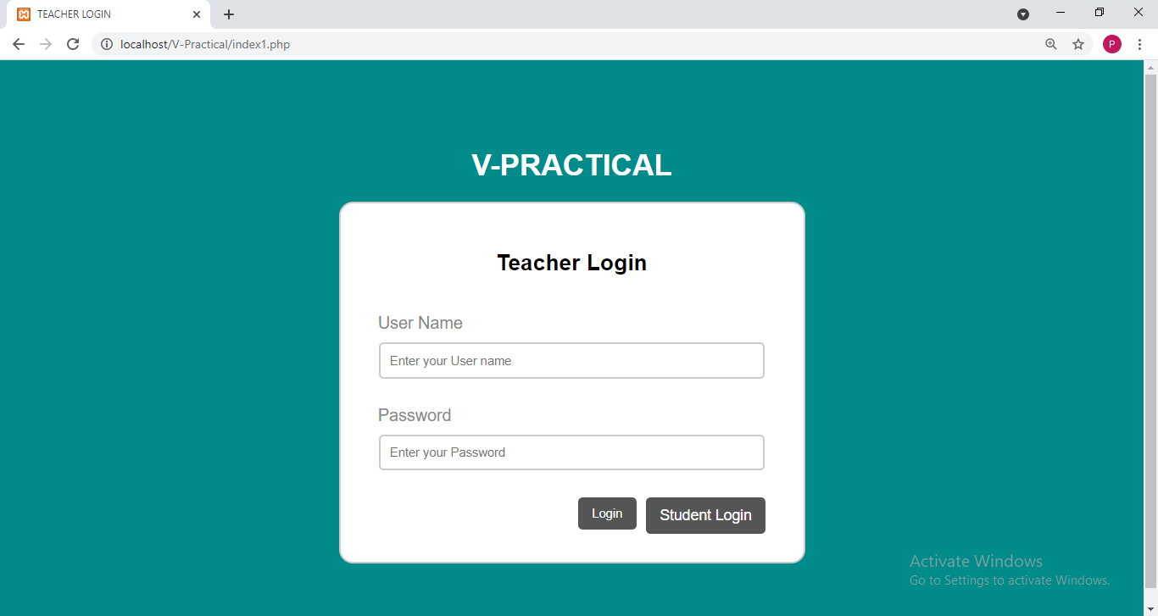

Fig10.1: Teacher’s Login

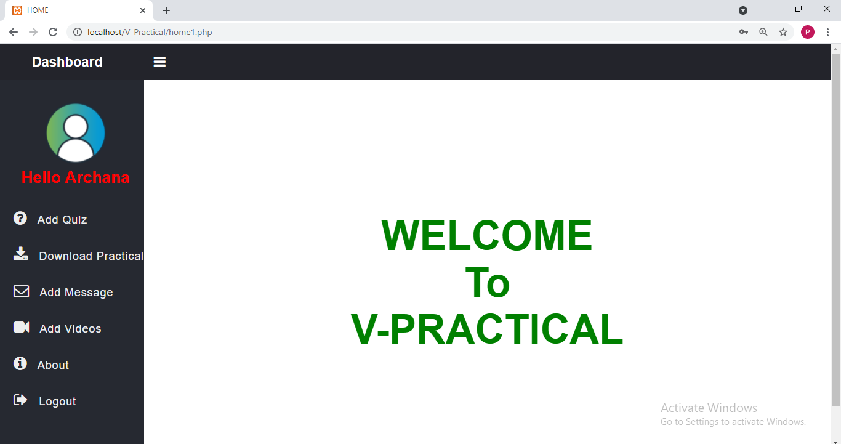

Fig10.2: Teacher’s Dashboard

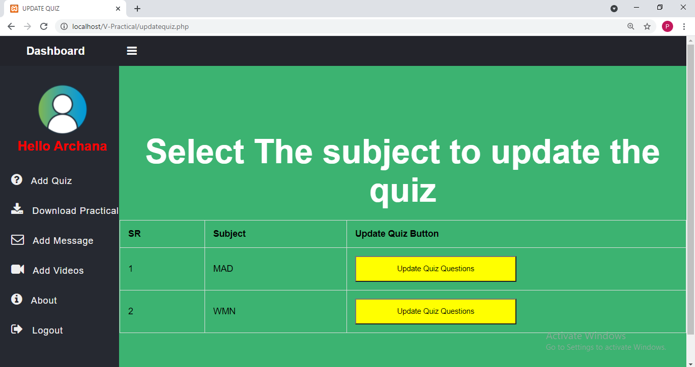

Fig.10.3: Update Quiz

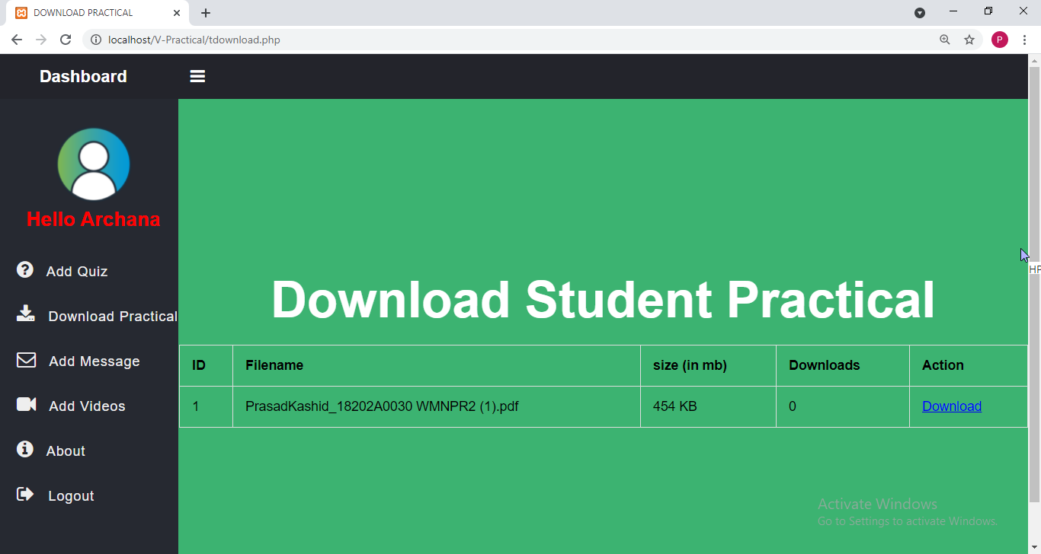

Fig.10.4: Download Practical

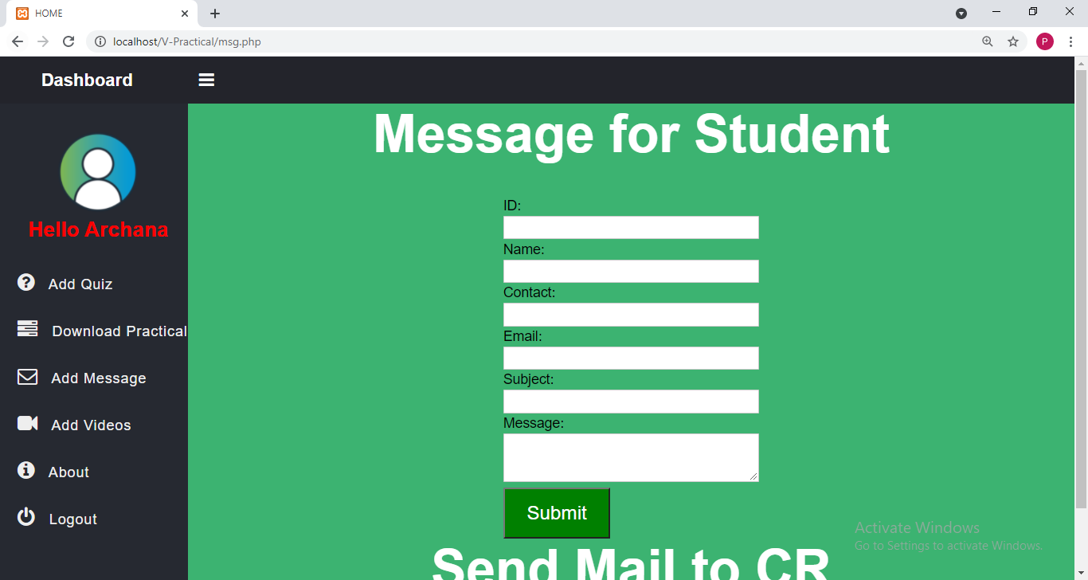

Fig.10.5: Add message

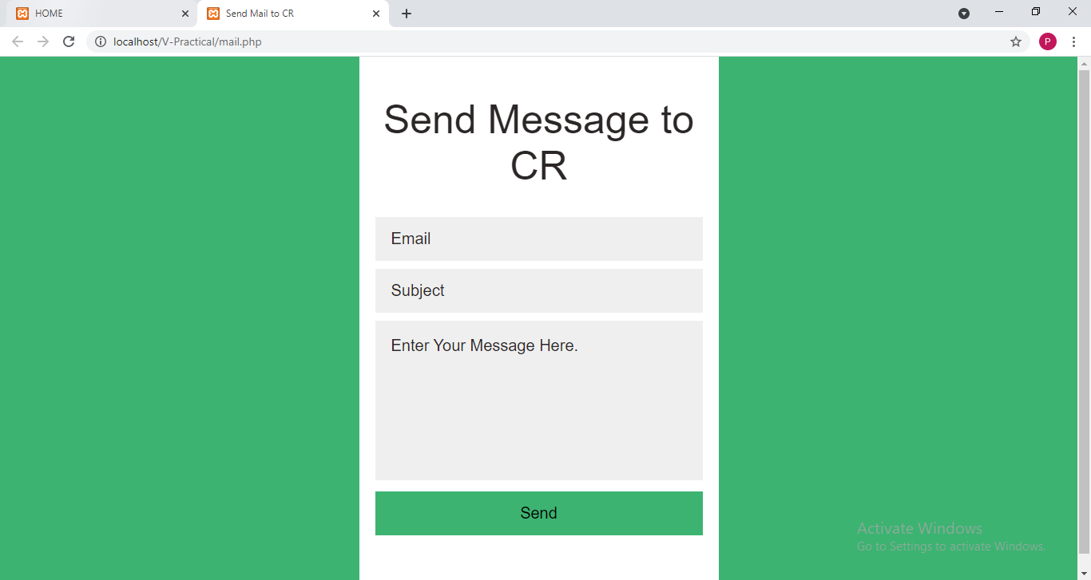

Fig.10.6: Send Mail to CR

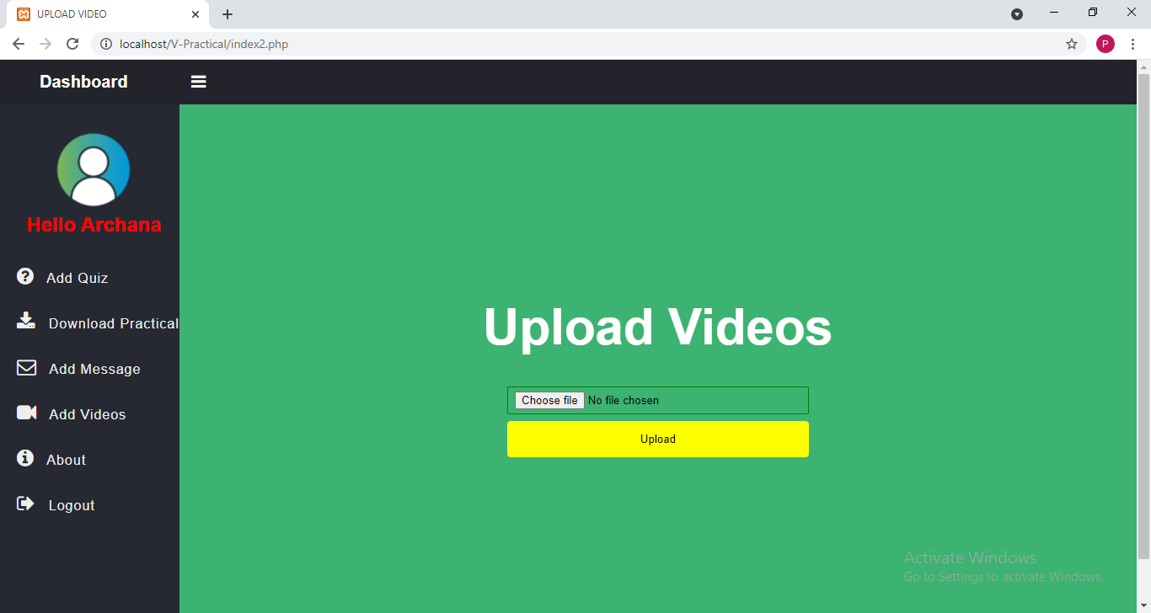

Fig.10.7: Add Videos

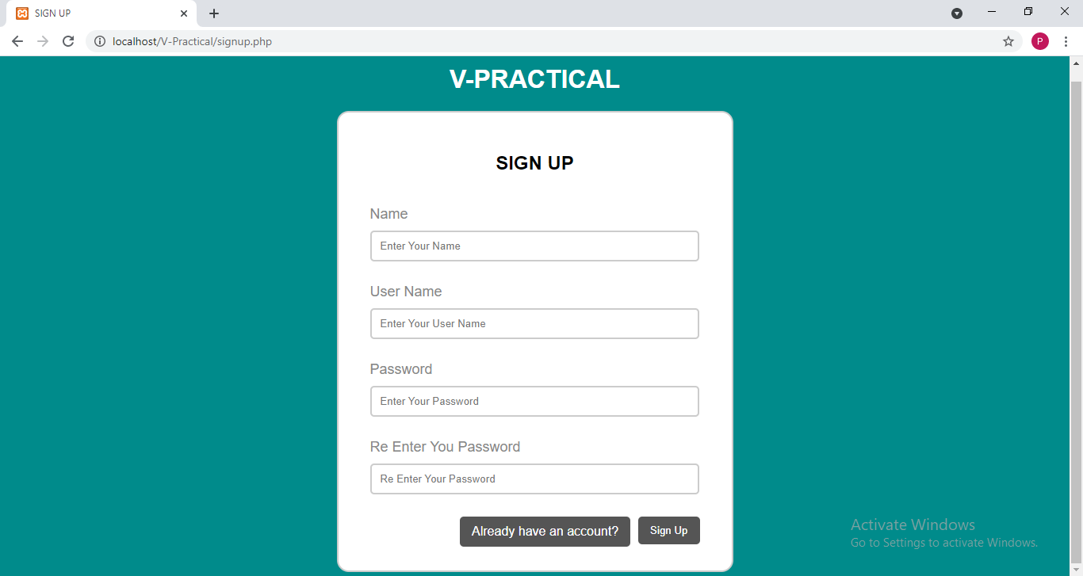

Fig.10.8: Student Registration

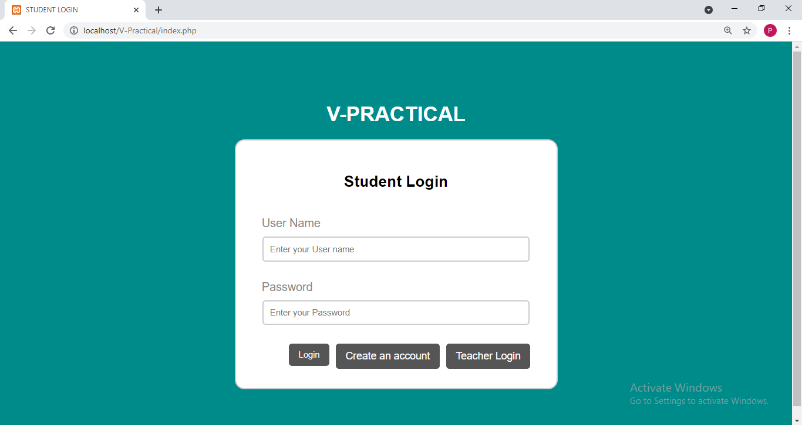

Fig.10.9: Student Login

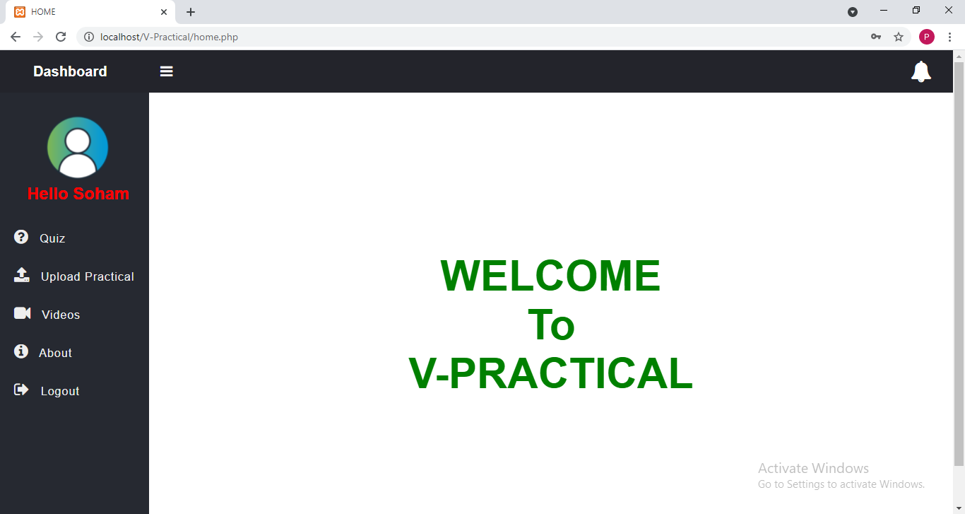

Fig.10.10: Student’s Dashboard

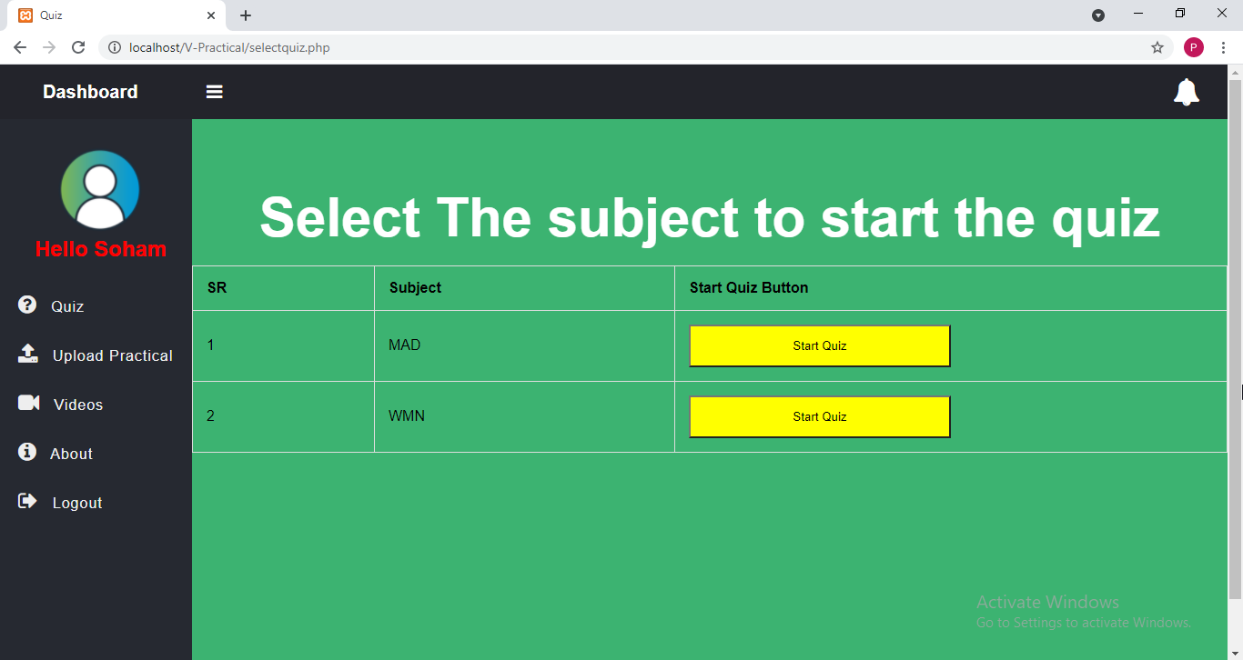

Fig.10.11: Select Quiz

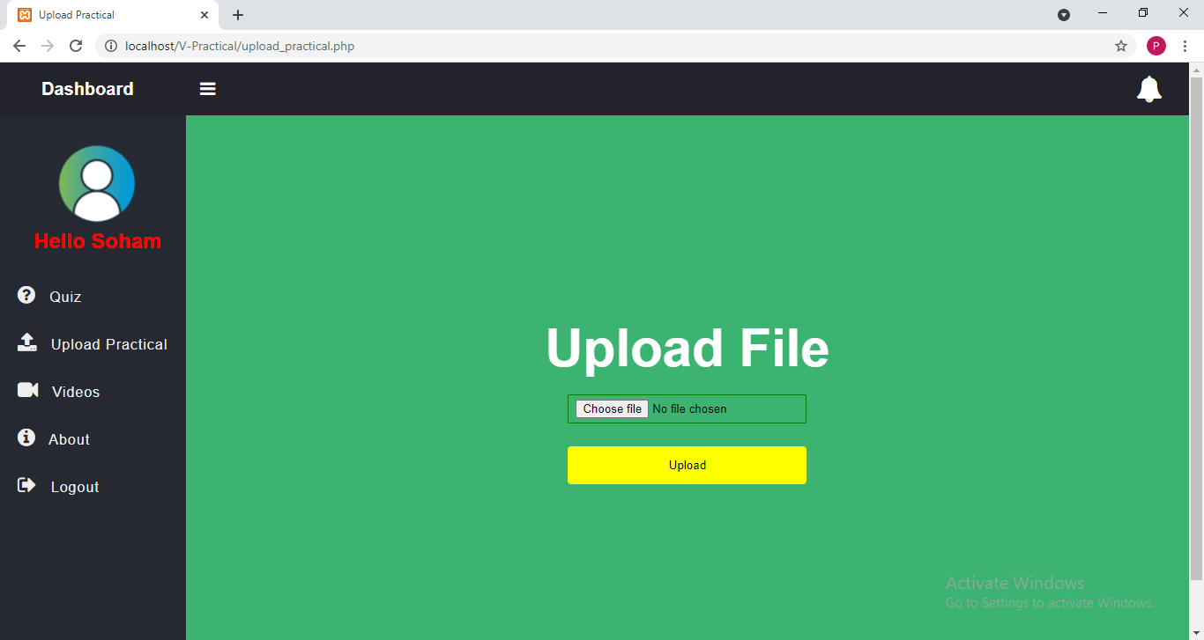

Fig.10.12: Upload Practical

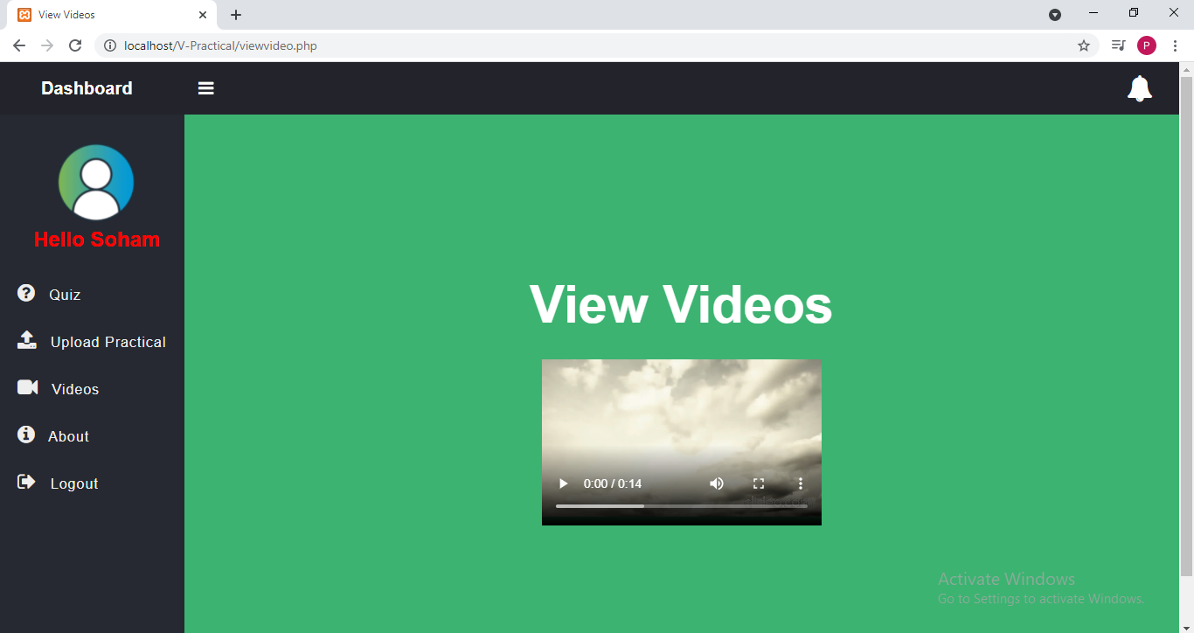

Fig.10.13: View Videos

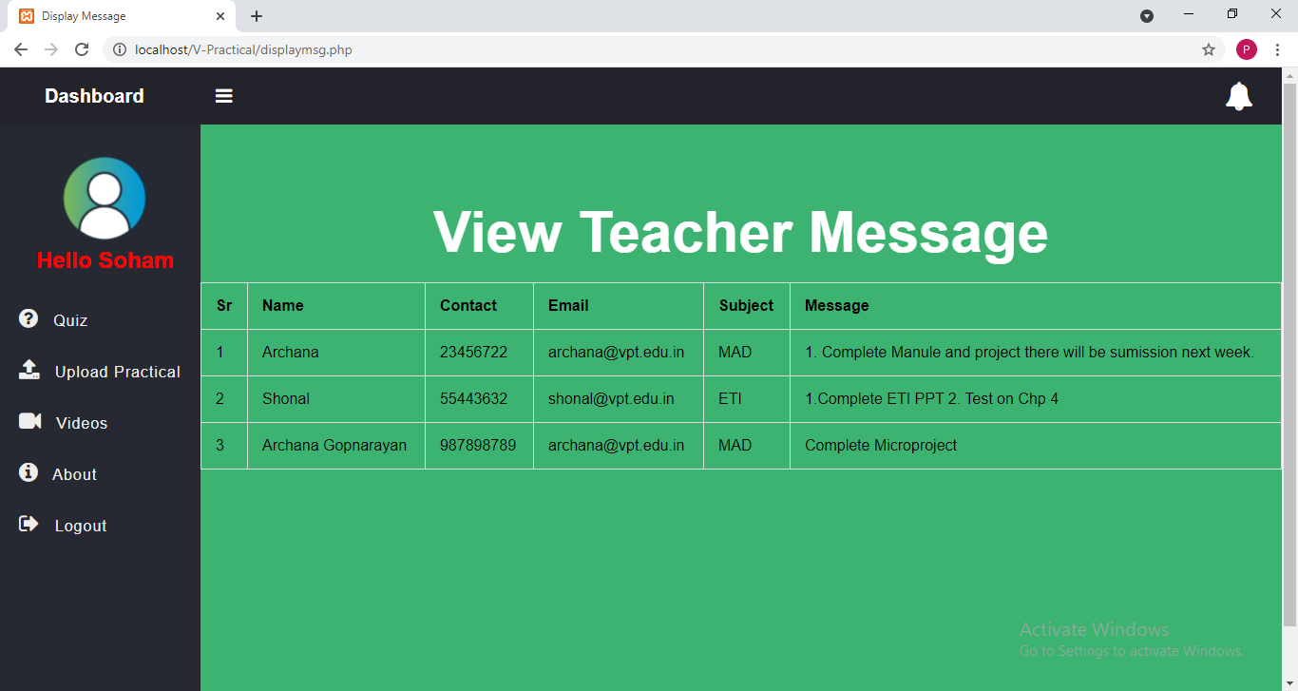

Fig.10.14: View Message

**CHAPTER 11**

**CONCLUSION**

# 11. CONCLUSION

A practical submission module is very essential for college/university. The proposed system is a web based application that provides facility for maintaining the practical data for teachers and students. It will help students to complete their practical and submit it online.Teachers can assess practicals of students.

**CHAPTER 12**

**BIBLIOGRAPHY**

# 12. References

* <https://www.researchgate.net/publication/281029040_Design_And_Implementation_Of_Online_Submission_and_Peer_Review_System_A_Case_Study_Of_E-Journal_Of_University_Of_Zakho> [1][2]
* https://www.tandfonline.com/doi/full/10.11120/ened.2009.04010016 [3]
* [https://www.rsisinternational.org/Issue7/306-309.pdf](https://www.rsisinternational.org/Issue7/306-309.pdf%20%5b4)  [4]
* <https://www.researchgate.net/publication/237527104_Case_study_of_a_computer_based_examination_system> [5]
* <https://www.researchgate.net/publication/277893852_Trends_in_the_Use_of_E-journals_A_Case_Study_of_PEC_University_of_Technology> [6]